# Russell Wheeler

Dr.Yurik

CS-255-J7197

05 February 2023

# CS 255 Business Requirements Document

Complete this template by replacing the bracketed text with the relevant information.

This template lays out all the different sections that you need to complete for Project One. Each section has guiding questions to prompt your thinking. These questions are meant to guide your initial responses to each area. You are encouraged to go beyond these questions using what you have learned in your readings. You will need to continually reference the interview transcript as you work to make sure that you are addressing your client’s needs. There is no required length for the final document. Instead, the goal is to complete each section based on your client’s needs.

**Tip:** You should respond in a bulleted list for each section. This will make your thoughts easier to reference when you move into the design phase for Project Two. One starter bullet has been provided for you in each section, but you will need to add more.

## System Components and Design

### Purpose

*What is the purpose of this project? Who is the client and what do they want their system to be able to do?*

* The purpose of DriverPass is to provide better driving training to better prepare drivers for the driving test at the Department of Motor Vehicles (DMV).

### System Background

*What does DriverPass want the system to do? What is the problem they want to fix? What are the different components needed for this system?*

* The client wants DriverPass to allow students to take online tests, study and schedule in person driving tests in order to better prepare students for the DMV drivers' test.

### Objectives and Goals

*What should this system be able to do when it is completed? What measurable tasks need to be included in the system design to achieve this?*

* Access data anywhere Online and Offline
  + From Mobile and Computer
  + While online you can download information in an Excel compatible format.
* Rights and roles for users
  + Tracks changes made by each user
    - Leaves associated timestamp and actions made
* Reservation system tracking who what when where
* Users can take and complete online tests

## Requirements

### Nonfunctional Requirements

*In this section, you will detail the different nonfunctional requirements for the DriverPass system. You will need to think about the different things that the system needs to function properly.*

#### Performance Requirements

*What environments (web-based, application, etc.) does this system need to run in? How fast should the system run? How often should the system be updated?*

* Program will be run from the cloud and will need an online portal
* Application that can be ran offline with limited capabilities
* When online the program will always be up to date

#### Platform Constraints

*What platforms (Windows, Unix, etc.) should the system run on? Does the back end require any tools, such as a database, to support this application?*

* Operating systems include
  + Windows
  + IOS
  + Android
* Cloud required for database storage and management

#### Accuracy and Precision

*How will you distinguish between different users?* *Is the input case-sensitive? When should the system inform the admin of a problem?*

* Rights and roles:
  + Big boss
  + IT officer
  + Secretary
  + Drivers
  + students
* The admin should be informed when a user other than student is locked out
* The admin should be informed when a security threat is detected
* Usernames will distinguish users and will not be duplicated

#### Adaptability

*Can you make changes to the user (add/remove/modify) without changing code? How will the system adapt to platform updates? What type of access does the IT admin need?*

* The admin will not be able to add or removed modules without a developer
* The admin will be able to disable packages to prevent customer purchase
* Platform updates will be requested upon new systems being released

#### Security

*What is required for the user to log in? How can you secure the connection or the data exchange between the client and the server? What should happen to the account if there is a “brute force” hacking attempt? What happens if the user forgets their password?*

* Username and password will be required for login
  + If logging in from a new device two step verification may be required
* Brute force hacking attempts will be limited due to limiting the number of password attempts
  + Resetting the attempts will require user verification

### Functional Requirements

*Using the information from the scenario, think about the different functions the system needs to provide. Each of your bullets should start with “The system shall . . .” For example, one functional requirement might be, “The system shall validate user credentials when logging in.”*

* The system shall validate user credentials when logging in
* The system shall update the server when changes are made
* The system shall allow users to make reservations
* The system shall allow the admin to reset passwords or users and team members
* The system shall track reservations made and display them, so they are easily seen
* The system shall allow students to take practice tests

### User Interface

*What are the needs of the interface? Who are the different users for this interface? What will each user need to be able to do through the interface? How will the user interact with the interface (mobile, browser, etc.)?*

* The different users directly reflect the roles and rights listed previously
  + Big boss
  + IT officer
  + Secretary
  + Drivers
  + students
* The interface will need to allow the user to accomplish all goals and tasks described in this document
* The following is the interface diagram provided by the client that the student driver will see

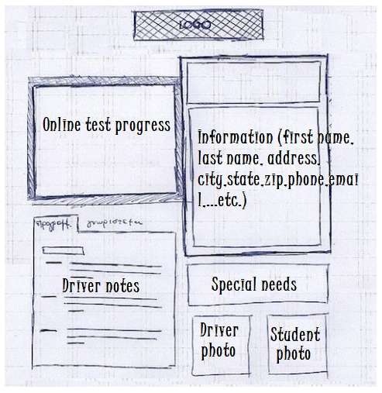

### Assumptions

*What things were not specifically addressed in your design above? What assumptions are you making in your design about the users or the technology they have?*

* Users have access to internet
* Users have up to date mobile and computer devices
* Users have practice tests as well as other testing resources

### Limitations

*Any system you build will naturally have limitations. What limitations do you see in your system design? What limitations do you have as far as resources, time, budget, or technology?*

* When offline the system cannot be updated until it is synced to the server
* The number of user accounts may be limited to the size of server and plan purchased by client
* The application will require updates when device updates are presented, more so for mobile devices than computers

### Gantt Chart

*Please include a screenshot of the GANTT chart that you created with Lucidchart. Be sure to check that it meets the plan described by the characters in the interview.*

